Bandit level 10 to level 11
To login to the level 10 use the username as
Next use ls command to list the files.
And then use the command base64 -d data.txt which is used to decode the base64-encoded content in the file and display the original data.
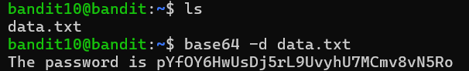
Finally we get the password for the next level 11.

